Continuing Studies Fund:
Policy Document

- Lay applicants are now eligible to apply for support through the Continuing Studies Fund (CSF). This funding is provided by the Discipleship Development Fund (DDF) and administered by the Education and Learning Finance Sub-Committee.

- This funding is not available to lay members outside the United Reformed Church working with other denominations.

- A number of activities are already eligible for support from the Continuing Studies Fund:
  - Part-time study for higher degrees. Funds might, for example, be used towards the payment of fees, research expenses, or the cost of having the thesis bound in the requisite number of copies.
  - Professional development programmes such as CIPD (Chartered Institute of Personnel and Development).

- The fund offers a maximum annual amount of up to £350 for a Bachelors’ degree, Graduate Diploma, or professional development programme and up to £500 towards a Postgraduate Diploma, Masters or PhD. If the applicant is an Assembly Accredited Lay Preacher, they can put their £300 annual grant towards this. Repeat requests are allowed throughout the duration of study.

- Applications can also be made for a broad range of subjects, not just theological. For example, bookkeeping courses for treasurers and MS Word courses for secretaries will be considered.

- There are five conditions to be met before a grant will be considered:
- The applicant must be someone who serves the URC in a voluntary capacity, needs to have been a member of a URC for at least two years and remain a URC member throughout the duration of the course.
- The application needs to be for a course from a recognised establishment.
- The applicant must explain how this learning will enhance or support their role/ministry in a local church context.
- All the remaining funding needs to be in place before a grant is given.
- The form needs to be endorsed by both the local church and the Synod.
- Applications for this support should be made to the Secretary for Education and Learning by the Synod Officer responsible for lay training, using the designated CS2 application form (below). Assembly Accredited Lay Preachers should also include a signed and completed copy of the A4 Lay Preachers’ form with their request.

- Forms can be submitted at any time, but the annual closing date for applications is 30 June. Decisions are normally made in early July ready for the start of the academic year.

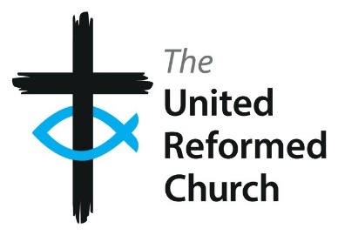
Education and Learning
CS2 form
Continuing Studies Fund for lay applicants

Application Form Ffor
Print
Save
This funding is for help with the costs of continuing studies as described in the accompanying policy document.
Applications should be forwarded to the Secretary for Education and Learning by the Synod Officer responsible for lay training. Only one application per person per academic year may be submitted. The annual closing date for applications is 30 June.

Name
Address
Email
Telephone Synod
Course of study being undertaken:
Amount requested from the Continuing Studies Fund:
Institution:

Start date and expected completion date of these studies: Academic year for which you are currently requesting funding:
Full course costs for the relevant academic year:

Please give details of other funding you have already been awarded towards these studies, eg Lay Preachers’ grant, Coward Trust, Continuing Studies Fund etc:
Signature:
Date:
Signature of Synod Officer
Date:
Pastorate

