OCTOBER 2022
SAFEGUARDING
NEWSLETTER
TRAINING UPDATES
FOUNDATION E-LEARNING
The Foundation course is now available via E-
learning. If you are interested in this course please contact your Synod Safeguarding Officer. The Foundation module will be available as a face to face course in 2023. Please contact your SSO
if you would like to book Foundation training.
ELDERS
The next training sessions are March 14th 2023 7pm-9pm and October 20th 1pm-3pm 2023 .
This training introduces Elders to the role they play in Safeguarding. Please contact
Carrie.Kaunda@urc.org.uk to book onto this. The training will take place on Zoom and last
approximately 2 hours. This is vital training to give Elders information about their legal
responsibilities in Safeguarding in relation to their role as a Trustee.
DBS VERIFIERS AND SAFER RECRUITMENT TRAINING
This training is provided by Matt Tuckey from DDC and Carrie Kaunda from the Central
Safeguarding team at Church House. This is important for those who have a role in recruiting
paid and volunteer staff in their church. The next dates will all take place over zoom, the date is 15th November 7pm-9pm. The session lasts two hours. Please
contact carrie.kaunda@urc.org.uk to book a place.
SYNOD SPECIFIC TRAINING
The Foundation and Intermediate modules form part of the mandated training modules required by the URC. The below sessions are run on Zoom. Foundation training: 3rd November 6.30pm 13th December 7pm Intermediate training: 21st November 6.30pm 16th December 7pm. Contact Belinda your Synod Safeguarding Officer to book this training.

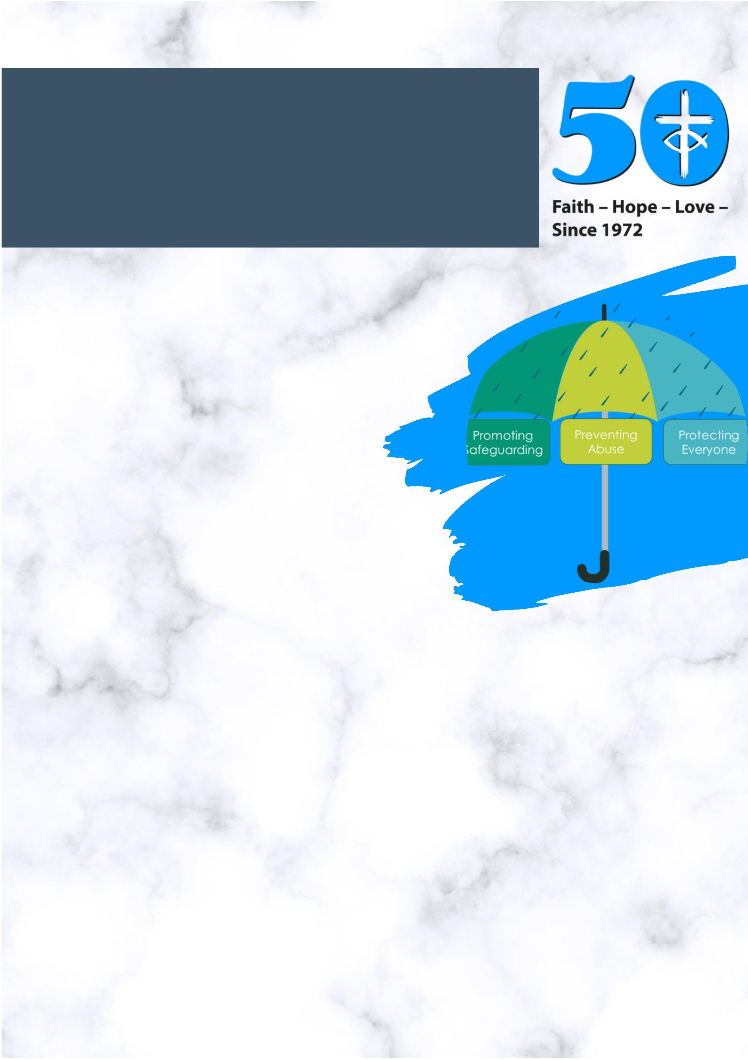

STAFFING
The Safeguarding Team has welcomed Kerry Baker as Policy
Development Coordinator and she is currently working on updating Good Practice 5, if
you would like to be involved in this process then please email her
Kerry.baker@urc.org.uk .
.
SAFEGUARDING
COMMITTEE
Speak up for
those who
cannot speak
for themselves
The Safeguarding Committee had their first meeting
on 15th September. This committee replaces the
Safeguarding Advisory Group. One of the topics
raised was around Youth Work in private dwellings.
there is further information on the guidance
produced by the URC on the Safeguarding section
of the website. You can access the link opposite.
PROVERBS 31.8
C L I C K L I NK HE R E
HOSTING REFUGEES
If you want to host a Ukrainian refugee family, you must record your interest as an individual
here. The publication Guidelines for safeguarding refugees and asylum seekers written by
Churches Together and Thirty-One Eight is a useful document to look at, this addresses
safeguarding issues more widely faced by churches wanting to reach out to refugees and
asylum seekers. The Synod of Wales has also produced additional guidance which may be
obtained by emailing
diana.taylor.urcwales@urc.org.uk
C L I C K L I NK HE R E

REVIEW OF GOOD PRACTICE 5
We have started reviewing Good Practice 5 and are aiming to issue an updated version next
year. We will be consulting with people in different roles across the URC and want to gather as
much feedback as possible to help with revising the guidance. Further details and timescales
will follow but if you have any questions about the review in the meantime, please contact
kerry.baker@urc.org.uk.
URC APOLOGY
The United Reformed Church (URC) has made a confession and apology for the role of its
antecedents in transatlantic slavery and its continuing complicity in the legacies of the
trade today.
At its General Assembly, held from 8-11 July at The Hayes Conference Centre in Swanwick,
the URC passed two resolutions pertaining to the topic. Further information on this can be
found on the website. See link opposite.
C L I C K L I N K HE R E
CHILD Q
You may have read of the case of Child Q where Met Police officers were suspended on
charges of gross misconduct for the strip search of a 15-year-old Black Girl. The publication
of a safeguarding review into the incident by the City and Hackney Safeguarding Children
Partnership, found racism was a likely “influencing factor” in Child Q’s treatment. The URC is
fully committed to fighting racial injustice and supports the Children’s Commissioner’s
office investigation into this.
The Children’s Commissioner has the following ambitions to improve the safeguards for
children to ensure that children are kept safe.
Ambition 1) Ensure the safeguarding of children is the top priority for the police when
undertaking searches, by amending national guidance
Ambition 2) Improvements to transparency and scrutiny
Ambition 3) Increased training
Ambition 4) Build upon the role of safeguarding partnerships
The Full Report can be found on the link opposite.
C L I C K L I N K HE R E

