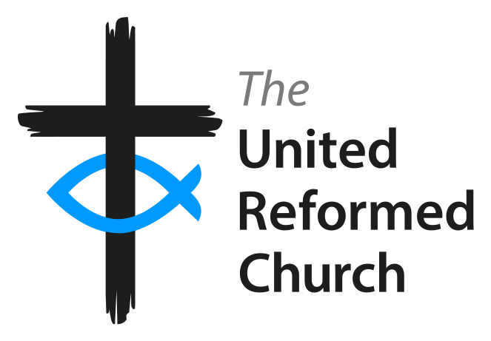
Safeguarding people
in the midst of
coronavirus

The Coronavirus (Covid-19) threat continues to emerge in the UK and throughout the rest of the world. At these difficult times, we would like to help churches not only promote everyone’ wellbeing but also consider actions for those who are more vulnerable in the next weeks and months.

As churches close for the foreseeable future, everyone needs to keep safeguarding a priority even if not meeting and ensure care for the more vulnerable through phone calls, messages and WhatsApp groups.

There are many initiatives to help people connect via the internet, though streaming and other measures. There is a range of advice on the URC website

Home visits

If you have to undertake home visits for any purpose, you are advised to take precautions, or to consider alternative ways of keeping in touch.

The Methodist Church shares top tips for those receiving visits as well as for those who are undertaking them here. It is paramount to ensure that the elderly, impoverished families and the vulnerable have food and essential provisions and access to support relevant to their needs during these challenging times.

Under current circumstances, it is also essential that Elders, ministers, CRCWs, church safeguarding coordinators and those with pastoral responsibilities need to make sure that communication with under 18s and vulnerable people is kept within government and health guidance about levels of contact and self-isolation.

Where people are living in their own homes, with or without additional support from friends, family and carers, the government has provided specific guidance that can be accessed here.

Children and young people

In alignment with relevant government guidance regarding closure of schools and colleges, all children and youth-related activities, events and services are advised to be suspended for the coming weeks. This includes mentoring sessions, Sunday schools and messy groups. It would be risky to replace formal meetings at your church premises with informal meetings at the home of youth leaders or ministers.

Provide information to and educate children and young people about coronavirus and enable parents/carers to discuss the situation with them. The Charity Save the children provides valuable guidance on this here.

Adults at risk

The government already identified adults who are at increased risk of severe illness from the virus. This includes those who are pregnant, those who are aged 70 or older, with or without health conditions, and other groups who may be at particular risk due to complex health problems such as:

- people who have received an organ transplant and remain on ongoing immunosuppression medication
- people with cancer who are undergoing active chemotherapy or radiotherapy
- people with cancers of the blood or bone marrow such as leukaemia who are at any stage of treatment
- people with severe chest conditions such as cystic fibrosis or severe asthma (requiring hospital admissions or courses of steroid tablets)
- people with severe diseases of body systems, such as severe kidney disease (dialysis).

Those who fall into above categories need to be at the centre of our care and support in the upcoming weeks along with people who are living with mental health issues, disabilities and learning difficulties and any person who rely on others ‘personal assistance to meet their basic needs.

Regular contact and texts over the phone will be a valuable source of help for those who require a reminder of medication or need someone to order food supplies. Our duty to safeguard individuals does not stop during the epidemic. We can identify key services in our local area and signpost vulnerable people who are at risk or might be at more risk due to coronavirus outbreak to local support services.

Access to specific advice and support

Some individuals might need specific help depending on their personal wellbeing and life circumstances. Below it is a list of specialist advice issues by different organisations.

- The National Eczema Society has offered advice on handwashing techniques for people with eczema and other skin conditions.

- Carers UK has issued recommendations for carers.

- Cancer charities have worked together to produce information on Covid-19 for anyone affected by cancer.

- Diabetes UK has provided an updated information page for people living with diabetes.

- Age UK has also provided advice on how to stop the spread of the virus, and actions to take.

- Asthma UK has released a blog post with advice for people with asthma.

Domestic abuse

Reports from China revealed that incidents of domestic abuse increased following the outbreak of the virus. If you are aware of risks of domestic violence against children, men and/or women, remain in contact with the family on a regular basis, provide affected members the contact details of Women’s Aid telephone number 0808 2000 247 (24-hour helpline) and make a prompt referral to children’s or adult case services in your local area.

Fraud

We also need to be careful about fraud. There are warnings about Covid-19 fraud and scams to be aware of. Action Fraud has issued a warning and information which is not specific to the faith sector. Read more here

In any case or situation, speak to Church Safeguarding Coordinator or the Synod Safeguarding Officer who can be of valuable help at these moments. Also, print and share the Appendix U of our recently updated safeguarding policy of the URC, which includes useful contacts for supporting people affected by different forms of abuse.

Any community events and services like foodbanks, lunch clubs, shelters for homelessness or other groups must follow guidance from the government.

Churches and their partner organisations might plan forward with the view to minimise, suspend and/or find alternative ways to run services for the benefit of the vulnerable groups. Another source of help can be advice provided by support organisations.

The Joint Public Issues Team (JPIT) have produced a simple guide on how you can support foodbanks during the coronavirus pandemic.

Likewise, the Trussell Trust has also issued guidance on how churches can support volunteer supported charities.

If a member or church attendee has been found infected by the virus, the church needs to take up all measures not to isolate this person from emotional or other support.

A telephone contact per day will be enough and very important for those who will be worried about their health and their unavoidable quarantine. In any case, the government’s guidance has to determine any action and contact with this person.

The epidemic of Coronavirus brings uncertainty, anxiety, even feelings of fear and panic. Whilst it is normal to feel worried, if someone is starting to feel overwhelmed, it’s important to acknowledge their feelings and share with someone they trust.

Charity Young Minds has issued advice for anyone feeling anxious about the virus. Mind has also offered information on what to do if you are worried about your wellbeing. There are also now more than 400 volunteer-led groups working to offer aid to people affected by the virus. See more here.

