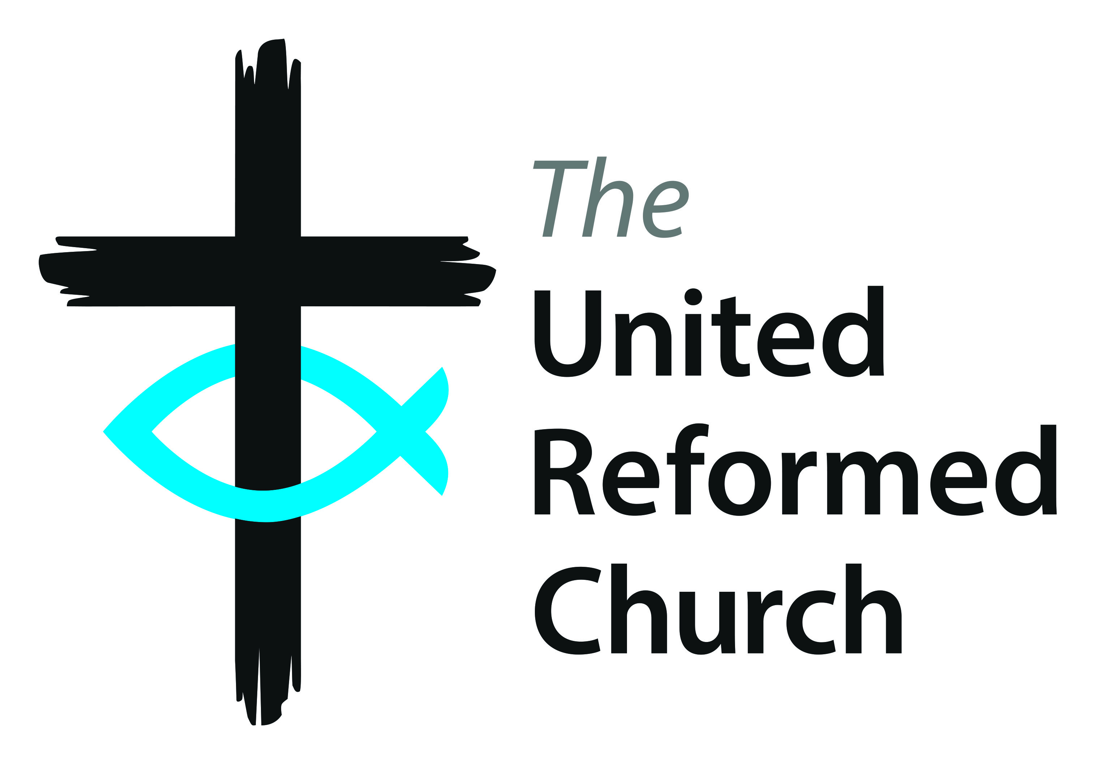
Southern Synod
Autumn Synod Together Meeting

Saturday 14 March 2020 10:30 am – 4:30 pm
Church Church URC, Tudor Way, Pett’s Wood Kent BR5 1LH.

AGENDA
Theme: One World, God’s World
- (9:30am-10:15am) Arrival and Registration in the Hall.
- Coffee/Tea & biscuits will be served in the Hall.
- The Synod Together Meeting will be in the Sanctuary.

- (10:25 am) Health & Safety Notices (Petts Wood)
- (10:30 am) Constitution of Synod Together (GW)
- Synod Roll & Apologies for absence (BB)
- Opening Worship and Bible Study (Alex Mabbs)
- Pastoral News (BB)
- Appointment of Tellers (GW)
- Minutes of the Meeting held on 12 October 2019 at Reigate Park URC (GW)
- Matters Arising (not covered elsewhere on the Agenda). (GW)
- Committee Reports
  - Synod Council & Synod Ministries [PAPER A] (GW & BB)
  - Finance (John Denison)
  - Property (David Walters)
- One World, God’s World
  - Stories from Churches (St John’s, Marsh Green & Christ Church URC, Petts Wood)
  - Resolution from Trinity URC, Wimbledon [PAPER B] (Dominic Grant)
- Welcome to Christ Church URC, Petts Wood & directions for lunch (Petts Wood)
- Grace (GW)
- One World, God’s World – Group Discussions

15. Break for lunch (1:15 pm – 2:15 pm) – Soup and tea/coffee to be served in the Hall

(2:15 pm) AFTERNOON SESSION

- Introduction of new Area Officers, Ministers, Local Church Leaders, and Farewells etc.
16.1 Presentation of Certificates to Lay Preachers
- Welcome to Synod Safeguarding Officer and introduction to her work (Belinda Nielson)
- Report on URC Educational Visit to Israel/Palestine September 2019 (Hannah Jones)
- Feedback from Discussion Groups
- Closing Worship (BB)
21. Closing of Synod Together Meeting (GW)
22. Refreshments

The Autumn Synod Together Meeting on Saturday 10 October 2020 (10:30 am – 4:30 pm)
at Brighthelm URC, Brighton or at a venue to be advised.

