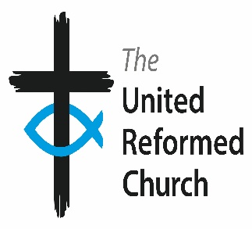
Southern Synod

Synod Office

East Croydon URC, Addiscombe Grove, Croydon CR0 5LP

Telephone 020 8688 3730 Fax No 020 8688 2698

www.urcsouthern.org.uk

Synod Church Building Fund Panel

Terms of Reference
1. Scope and Purpose
1.1 The Synod Church Building Fund Panel (the “Panel”) is a sub-group of Synod Council as approved by Synod Together and will report directly to the Council as required. It has delegated authority from the Synod Together on church building grants and loans provided to churches within the Southern Synod of the United Reformed Church.
1.2 The Panel is committed to supporting the Mission Criteria of the Southern Synod and making judgements in the light of synod policies for the use of the Fund. It seeks to be aware of the economic, political and social context of life in Southern England and is committed to the proper care and administration of the Synod’s resources.
1.3 The Panel will have an annual budget agreed by Synod Together. If the Panel wishes to exceed its budget or wishes to seek advice on exceptionally large grants the Panel will liaise as necessary with the Property and Finance Committees as well as with Synod Council.
2. Membership
2.1 The membership will be determined and approved by Synod Council. The Panel will be made up of:
Convenor of the Property Committees
Convenor of the Finance Committee
A representative from the Property Committee
A representative from the Finance Committee
The Synod Moderator (ex-officio)
The Synod Property Officer will act as non-executive secretary.

2.2 A Convener appointed from amongst the membership by Synod Council.
2.3 The Panel may invite other people to attend all or part of its meetings.
2.4 The Panel may co-opt additional members as it sees fit. All co-opted members of the Panel will require ratification under nominations from Synod Council.

2.4 Conflicts of interest must be declared at meetings and duly minuted. The member may be asked to absent themselves from the discussion and must not vote.
2.5 The Panel may refer matters for consideration to a sub-group, which will report back to the Panel for a decision as required.
3 Meetings
3.1 The Panel will typically meet four times each year or as applications dictate. It will normally deal with applications for up to £20,000 by email between physical meetings.
3.2 The quorum for decisions will be a minimum of 3 voting members, including at least one member each of the Property and Finance Committees.
3.3 Decisions will normally be made within a month of receipt of the application and the Secretary will notify the applicant church if this is not possible.
3.4 Regular reports will be given to Synod Council, Synod Trust and to Synod Together.
3.5 The Panel will keep minutes of its meetings.
3.6 It is expected that decision making will be by consensus. In exceptional circumstances where consensus cannot be achieved, decision making will be by a majority vote of members present. In the event of a tied vote, the Convener will have an additional casting vote.
3.7 Outside meetings, matters of urgency as well as the smaller grants and loans may be dealt with via email Any matters dealt with in this way will be reported to the next meeting of the Panel.
3.8 All affirmative decisions awarding grants / loans will be communicated in writing to the Synod Finance Officer for information and action by the Secretary.
4. Alterations
Any proposed changes to these terms of reference will be the subject of agreement by Synod Council.

