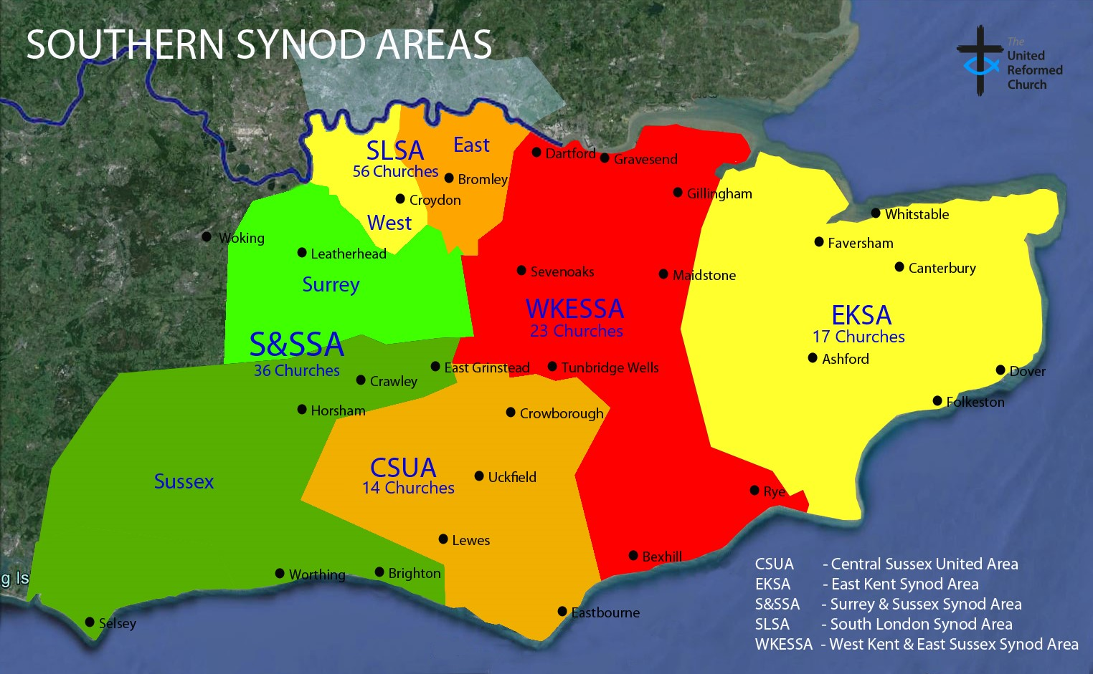
Introducing
Southern Synod

Welcome to Southern Synod of the United Reformed Church.

From South London to Kent to parts of Surrey and Sussex, whether coastal or country, urban or suburban we are God’s people in 146 local congregations committed to supporting and resourcing one another to be faithful followers of Jesus Christ. Together, we seek to be Christ’s people, transformed by the gospel, committed to making a difference to the world’s kingdoms as we live Christ’s kingdom.

Who we are:
The Synod is divided into 5 Areas: 4 Synod Areas (namely the East Kent Synod Area, the South London Synod Area, the Surrey and Sussex Synod Area and the West Kent and East Sussex Synod Area) and one United Areas (namely the Central Sussex United Area). Area meetings are held not less than 3 meetings per year for mutual support and encouragement as well as some devolved responsibility.

Synod Together meets twice each year, normally on the second Saturdays of March and October. Synod meetings are held in local churches, giving members of Synod the chance to see different aspects of the life and work of its churches.

About one third of our churches are United Churches. Ecumenical relationships generally are strong, with active ‘Churches Together’ bodies in Kent, South London, Surrey and Sussex and good co-operation among all the ‘Church Leaders’. In particular, the boundaries of the South East Methodist District overlap with those of the Synod, and a joint liaison group meets three times a year to exchange ideas and to encourage people to work together at a local level.

The Synod Office is located in Croydon at East Croydon URC. The office is well served by road (M25, M23) and rail services.

What we believe: Synod Mission Criteria

This Synod
- is committed to looking for new opportunities for being the church in the geographical area of the Synod

- is committed to supporting and resourcing the local churches to be faithful followers of Jesus Christ

- is committed to caring pastorally for its local churches, ministers and staff

- is committed to supporting and resourcing local churches to provide relevant, inspiring and engaging worship

- is committed to being aware of the economic, political and social context of life in Southern England and will seek to help local churches address the implications of these issues for their life and work

- is committed to the proper care and administration of its resources through its personnel, finances and buildings

- is committed to the wider of church of God through the United Reformed Church nationally, ecumenical relationships and the world church

- is committed to addressing issues of justice, peace and the environment

- is committed to regularly reviewing its life and mission in light of the above criteria always seeking the prompting and guidance of the Holy Spirit

Key Synod resource people include:
Synod Moderator In Vacancy
moderator@urcsouthern.org.uk

Synod Clerk Revd Derrick Sena Dzandu-Hedidor
synodclerk@urcsouthern.org.uk

Synod Treasurer Mr John Denison
treasurer@urcsouthern.org.uk

PA to the Moderator & Synod Clerk Ms Lauren Kane
modpa@urcsouthern.org.uk

Office and Finance Administrator Mrs Opuene Charles
office@urcsouthern.org.uk

Finance Officer and Trust Secretary Mrs Catherine Kingdom
financeandtrust@urcsouthern.org.uk

Property Officer & Deputy Trust Secretary Mr Colin McCracken
property@urcsouthern.org.uk

Property Administrator Vacant
propadmin@urcsouthern.org.uk

Children &Youth Development Officer Mr Tom Hackett
cydo@urcsouthern.org.uk

Ecumenical Development Officer Revd Dr Paul Dean
ecumenicalofficer@urcsouthern.org.uk

Mission Development Officer Mr Martin Hayward
missionofficer@urcsouthern.org.uk

Safeguarding Officer Ms Belinda Nielsen
safeguarding@urcthamesnorth-southern.org.uk

Training & Development Officer Revd Andy Twilley
training@urcsouthern.org.uk

Other resource people are listed in the Synod Handbook, and on the Synod website.

What we do:
The Synod Structures report in 2010 boldly declared that we strive always to be ‘Christ’s people ... transformed by the Gospel ... making a difference.’ This is why we exist, and as this vision becomes reality we seek to be a foretaste of the kingdom of God, which is justice and joy. With a renewed ecumenical focus we are driven by the Synod Mission Criteria which undergirds all our thinking. The Synod’s mission is to encourage and enable local churches in their mission. The structure must be such as to achieve this.

A. Synod Council
Functions
On behalf of and with powers delegated by Synod -
- Acts on behalf of Synod on matters requiring attention between meetings of
Synod Together;
- Has general oversight of the life and work of the Synod and coordination of
the work of the Synod Areas/ United Area (SA/UAs) as necessary;
3. Receives reports and decides on appropriate actions to be taken;
4. Thinks and acts strategically in respect of in supporting local churches in their
discipleship and mission;
5. Cares for and has oversight of Synod Field and Office staff;
6. Appoints and/or oversees the work of the committees, groups and coordinators
which deal with Synod-wide concerns (each of these designated bodies relates to
the SA/UAs as appropriate, is responsible to Synod Council, and has right of access
to Synod Council for consideration of these Synod-wide issues) as follows:
(a) Children’s & Youth Work
(b) Church and Society
(c) World Church and Mission
(d) Synod Strategic Mission Fund
(e) Synod Church Building Fund
(f) and such other concerns as Synod Council considers necessary.

Membership: Synod Moderator (Convener), Synod Clerk (Secretary), Synod Treasurer, SA/UA leaders, Conveners of Children’s & Youth Work, Finance, Ministries, Property and Trust Committees, Representative of the South East Methodist District, and URC Mission Council representatives.

B. Synod Ministries Committee
Functions
Care of Churches
a) To remain aware of vacancies throughout the Synod;
b) To receive and discuss matters of general concern referred to it by the Synod
Moderator, other Synod Officers, Synod Area Pastoral Committees (SAPCs).
c) To receive reports from the Synod Safeguarding Officer;
d) In consultation with the Synod Safeguarding Officer and the CYDO, ensure
that each local church has safeguarding policies in place and a designated Link person;
e) To work in conjunction with Local Church Leaders Advisory Group.

Care of Ministers, CRCWS, LCLs
a) Ensure that EM2 & EM3 provision is being met;
b) To receive report on general ministerial issues in the Synod from Moderator;
c) To verify that each minister etc. is entitled to work in the United Kingdom;
d) To approve sabbaticals;
e) Oversight of ministers together with SAPCs.

Deployment
a) To receive reports from the Deployment Group and oversee its work;
b) To review levels of deployment within the Synod in light of Assembly targets;
c) To ensure and monitor the implementation of the Deployment Policy.

Mission
a) To receive reports from the Mission Officer;
b) To keep informed of churches in the Synod involved with major initiatives
e.g. Vision 20/20

Candidates and Students
a) To receive reports from C&S committee and oversee its work;
b) To receive and discuss items of general concern;
c) To concur with the decisions of the Committee.

Lay Preaching
a) To receive reports from and oversee the work of the Lay Preaching Coordinator;
b) To oversee the implementation of the Synod's Lay Presidency Policy;
c) To ensure continuing provision of the Sacraments Course and appoint tutors;
d) To ensure training opportunities.

Local Ministry and Mission Review (LMMR)
- To implement LMMR in our Synod by drawing up guidelines and providing training;
b) To monitor its operation in all Synod Areas;
c) To receive reports from and oversee the work of LMMR Co-ordinator.

Strategic Ministries
- To ensure that the operation of Special Category Ministries and Synod Strategic
Ministries is consistent with the Synod’s Deployment Policy and Mission Criteria;
- To receive reports from and oversee the work of Special Category Ministries and Synod Strategic Ministries.

Ecumenical Matters
- To receive reports from the Synod Ecumenical Development Officer through SA/UA Pastoral Committee reports.

Training
a) To receive a report from the Synod Training & Development Officer;
b) To facilitate Synod wide training as appropriate.

Other Matters
To deal with issues of concern in churches and relating to ministries as they arise.

Membership: Convener, Secretary, Synod Council, SA/UA Pastoral Committee Conveners, Conveners of Candidates & Students, Deployment, LMMR and Lay Preaching.

In attendance: Children’s & Youth Development Officer (CYDO), Ecumenical Development Officer (EDO), Mission Development Officer (MDO), Property Officer (PO), Safeguarding Officer (SO), Training Development Officer (TDO). The Synod Officers are ex-officio members.

C. Finance Committee
Functions
On behalf of and with powers delegated by Synod:
1. Oversees all Synod finance matters;
2. Submits Synod budget to the Synod Trust for approval and, for information, for
Council and Synod Together for agreement.
- Allocates to and monitors budgets of Committees and Synod projects; considers
potential overspends;
4. Submits business plan to the Synod Trust;
5. Considers and, if appropriate, approves grant/loan applications from local churches (referred by SA/UAs and the Property Committee as appropriate);
6. As necessary, creates various sub-groups such as -
(a) Ministry & Mission (M&M) Group (to recommend to the Finance Committee the
allocation of targets for M&M contributions from the SA/UAs);
(b) Investment Policy Group.
Membership: Convener (Synod Treasurer), Secretary (Finance Officer), Minutes Secretary (Office and Finance Administrator), Conveners of Synod Council and Property, SA/UA Treasurers. The Synod Officers are ex-officio members.

D. Property Committee
Functions
On behalf of and with powers delegated by Synod:
1. Oversees all Synod property matters;
2. Oversees the Synod Manse Policy, and the buying and selling of manses;
3. Oversees quinquennial property visits;
4. Considers and, if appropriate, approves church building projects, referring
financial decisions (grants/loans) to the Synod Finance Committee with
recommendations;
- Creates sub-groups as required including -
Listed Buildings Advisory Committee (LBAC) - (Statutory requirement).

Membership: Convener, Secretary (Property Officer), Minutes Secretary (Property Administrator), Synod Council Convener, Treasurer, SA/UA Property Advisers, members with specific property/buildings expertise. The Synod Officers are ex-officio members.

E. Children’s & Youth Work Committee
Functions
- To provide an opportunity for the views of young people & those who work with
them in local churches to be heard, understood, represented to the Synod and acted upon appropriately;
2. To initiate, oversee and support Synod children’s & youth work initiatives/events and to set up working parties to implement them;
3. To encourage and appoint young people to be involved in Synod decision making
bodies (e.g. Synod meetings and Synod Area meetings) and to be involved at
Assembly level (URC Youth Assembly, General Assembly, etc.);

4. To agree the Synod Children’s & Youth Work budget annually and make decisions about how that money is spent.

Membership: Convenor, Secretary, Synod Children’s & Youth Development Officer (CYDO), Synod Youth Rep, Two representatives of Synod Youth Executive, people with varied experience & knowledge of children’s & youth work: Pilots, Brigades, Scouts & Guides etc. The Synod Officers are ex-officio members.

Please pray for the work of the Synod

May the Spirit of the Lord rest upon us;
may the call of God sustain us as we seek to be Christ’s people, transformed by the gospel announcing good news to the poor proclaiming freedom for those in prisons of wealth, poverty, disease and disorder committed to making a difference to the world’s kingdoms as we live Christ’s kingdom.
May we deploy our resources as the Spirit guides, not shirk difficult decisions about the priorities of mission, pledge ourselves anew to work with all our fellow Christians and use the gifts of all God’s people so that all may be filled with the Spirit of healing, justice and peace.

URC Catch the Vision prayer

December 2019

