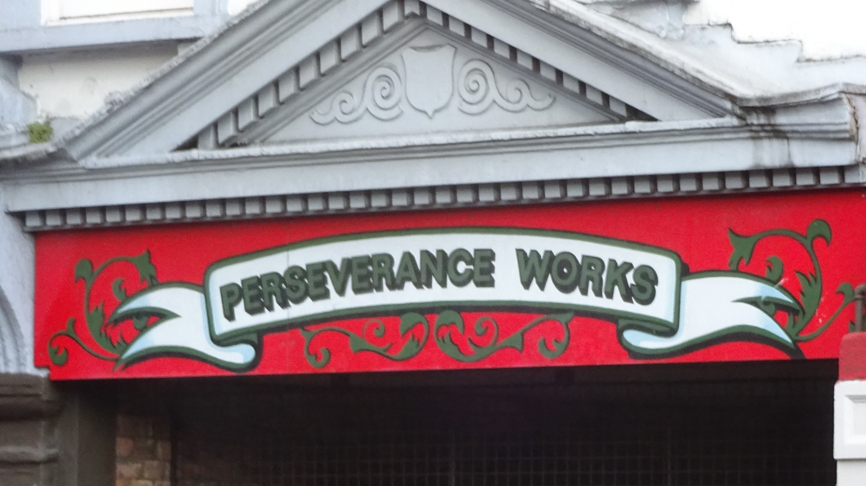
being brave in
brexit britain
Cause for Celebration, 2017

a day of workshops and celebrations for urban URCs and their friends organised by Urban URC Network
Saturday 17th June ’17, 10-4 @ Askew Road URC / Meth
in West London, near Stamford Brook (District Line) Tube

