***Music at Hungerford***

There isn't much live music in the town at present. A group called the Hungerford Singers used to exist, but folded when the director left the town in the 1980s. Recent attempts to enliven interest have found little support. Occasional recitals take place in the Church, especially during the festival (early July). There is however a great deal of musical activity based in Newbury.

***The Organ***

The instrument is a real gem, dating from the 1790s. It was thought to be from the Lincoln stable, but this has never been proved. It was originally in a Presbyterian Conventicle in nearby Shalbourne, which closed in 1838. This Church was extended in 1840 and the organ was moved here. It was rebuilt in 1908 by Alphonse Carey, who extended its range and added a second keyboard; it was this work that failed in the 1970s. The older part was refurbished in 1993-4 by Derrick Carrington. He would love to complete his restoration by rebuilding the second keyboard, but resources prevent this at the moment.

***Refreshments***

Coffee and tea on arrival, during the breaks and at lunchtime are

covered by the cost for the day. Participants should bring their own lunch.

***Cost***

£10 per member of URC Music and £12.50 for non-members.

***Travel, Accommodation & Parking***

Hungerford is situated about 3 miles south of J14 of the M4, on the A4 between Newbury and Marlborough. Hungerford railway station is on the line from London (Paddington) with an hourly service.

There are pubs with accommodation in Newbury, a Premier Inn close by just off the A339 and a Warner Hotel not far away.

There is ample parking close by in Hungerford and ramped access into the building.



Honorary President:

The Reverend Alan Gaunt

Patrons:

The Moderators of General Assembly

**Music Celebration Day 2017**

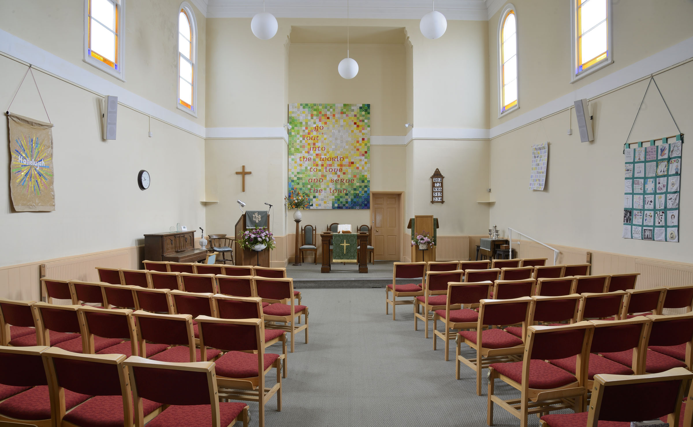

**Photo: Tony Bartlett**

**Hungerford United Reformed Church**

**Berkshire**

**SATURDAY 21ST OCTOBER**

**‘Reformed, Singing and Free’**

***Introduction***

This year URC Music will contribute to a programme of events taking place to celebrate the 500th Anniversary of the Reformation. Our Music Day will give members a wonderful and exciting opportunity to learn, improve and perform a small and perfectly formed piece written by a composer who will need no introductions but who did so much to promote the cause of the reformed tradition. Our performance of Bach’s Cantata 180 “Schmücke dich, O liebe Seele” - O soul, adorn thyself with gladness - will form the uplifting spiritual and musical core of our closing worship.

***Programme***

**9.45am Arrival, Registration & Coffee**

10.15 Welcome & Opening Worship led by Revd John Sturney

10.45 Workshop 1 – Improving our Singing

11.30 Break

11.45 Workshop 2 – Introducing our Cantata

**12.45 Lunch**

1.30 AGM

2.00pm Music in the Reformation : Revd David Bunney

2.30 Afternoon Workshop(s)

3.30 Break

3.45 Closing Worship

**5pm Depart**

***Cantata 180***

For those perhaps feeling over-awed at tackling an unfamiliar piece, a look at Rejoice & Sing 446 ‘Deck thyself, my soul, with gladness’ would make a user-friendly start. It is likely that we shall be using the Breitkopf edition of the score. If you have, or can borrow a copy, please bring it with you. ( It is hoped that some copies will be made available).

***A Brief History of Hungerford URC***

Nonconformity in Hungerford is assumed to date from the year 1662, but there is no authentic-record of a Church of Protestant dissenters until many years later. Only very scanty details survive of this early church and it is not certain exactly where worship took place so it is not until the early 1800s that the history of the present church begins. A Congregational Chapel was covenanted on Christmas Day 1805 with the support of the nearby church at Newbury.

The church was occupying its present ‘burgage’ plot on the west side of the High Street by 1810 when it was substantially enlarged to accommodate an increased congregation. Further enlargement and improvement was undertaken in 1840. In much more recent times, the church was again extensively re-furbished in 2004 to provide disabled access.

Hungerford currently has a membership of about 15. The church shares monthly services with Hungerford Methodist Church and is an active member of Churches Together in Hungerford.

***Ann Wright - our Cantata workshop leader***

Ann gained her BA (Music) at the University of Toronto and not long after came to England where, in 2005, she was appointed Director of Music at Bradfield College, Wiltshire. In 2014 she became Director of Education with the Voces Cantabiles Music Foundation. She is not only skilled and experienced in directing choirs but is totally passionate about singing. She works with two

professional *a capella* groups, one of which is VOCES 8, an important strand

of her work with the VCM Foundation. Ann has just recently become the director of the Three Rivers Community Choir based in Newbury.

URC Music is delighted that Ann has accepted our invitation to bring the

music of the Reformation alive for us today.